Preparing a traditional Scottish granite house for 2045 zero carbon
Introduction
Figure 1. Our granite home
Between 2006 and 2014, I worked on improving the energy efficiency of our newly purchased three-bedroom, two-story, granite, gas heated home (Figure 1). The details of the approach and work done is written up in a 77-page publication “Improving the energy efficiency of a traditional stone house” (Pringle, R.T.,3rd Edition, 2015). While the loft and ground floor were insulated using a mixture of glass fibre and rockwool, the external walls were stripped of their lath and plaster and replaced with a dry lining of Polyisocyanurate (PIR) plastic foam insulated sheeting (Celotex, Ecotherm) and plasterboard. Key to the successful installation is maintaining the ventilated void between the stone and the lath and plaster. The result has been highly satisfactory, with energy bills halved and comfort increased. Predictions by some professionals that the use of vapour proof PIR would result in damp walls have not been realised. The Scottish Government’s commitment to zero carbon buildings by 2045 suggests that the EPC of D obtained is not good enough and that I must revisit the insulation of my house to achieve a more sustainable energy consumption and carbon footprint. This paper therefore examines the present energy performance of the house, how its EPC can be improved, and how its heat loss would change with different types of insulation. The practical implications for retrofit assessors and builders are addressed and several recommendations made.
Temperature monitoring of house as presently insulated
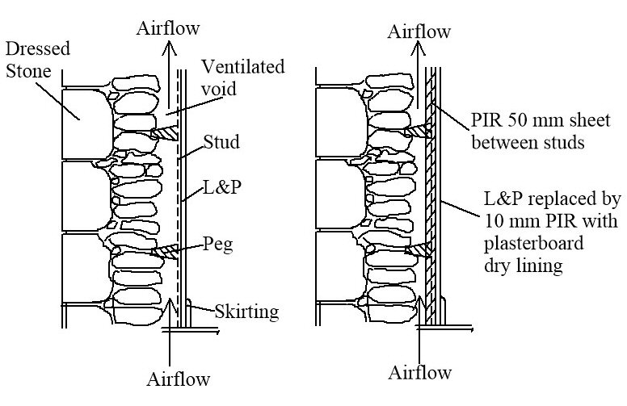
Figure 2. a) Wall and lath & plaster with ventilated void in between and b) PIR 50+10 mm, plus plasterboard replaces lath & plaster
The house is constructed of 600 mm width granite walls, dry lined with vertical studs and lath and plaster (Figure 2a). A 75-100 mm wide ventilated void, connected to the solum under the floor and in the loft space, is present in all the external walls and our neighbour’s party wall. Wall insulation (Figure 2b) was installed in most external walls of the house.
The partition walls between rooms are closed vertical boxes, the height and width of the rooms and 140 mm wide. A number of these have been used as conduits for wiring and plumbing, so have holes made in them, which permit some air exchange to atmosphere.
Over the winter of 2021-2022, temperatures within the house structure were monitored. The house heating is on a zone control sequence shown in Table 1. When any heating is on anywhere, the thermostatically controlled radiators in the bathroom and upstairs and downstairs hallways are also on.
Table 1. Zone heating times
Rooms | Morning | Afternoon
Kitchen & Dining room | 7:00 - 9:00 | 17:00 - 18:30
Lounge |  | 18:00 - 22:30
Upstairs rooms | 7:00 - 8:00 | 21:00 - 23:00

The graphs of the temperature monitoring show that the temperature, Figure 3, (a), within the void of the lounge partition wall is very similar to that of the room, both sensors being 1.5 m above floor level. As the skirtings have been well sealed with silicon, the heat into the partition must enter mainly by conduction through the lath and plaster. The U-value of lath and plaster is 3.69 W/m²°C, i.e. highly conductive. The rate of heat loss through wind induced adventitious ventilation in these partitions seems likely to be small.
Since warm air rises, air from the lower floor partition voids would be expected to rise to the first-floor partition voids. In two previously owned flats, with a neighbour below, heat from their flat entered the partition walls, rose, and radiated heat to the rooms on our first and second floors. This is not happening (Figure 3, (b)), as the front bedroom partition void and the bedroom are within 0.7 C of each other, while the lounge partition void is 3.3 C warmer than the bedroom void. This would suggest the partition wall void is closed at first floor height.
Figure 3. Room and void temperatures of granite house
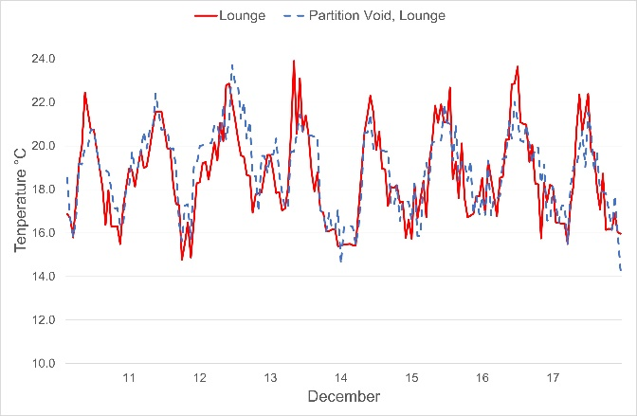 | 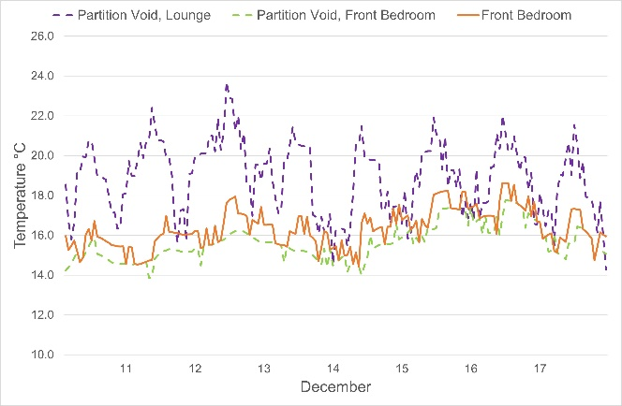
(a) Lounge and partition temperatures | (b) Partition void temperatures, ground and first floor
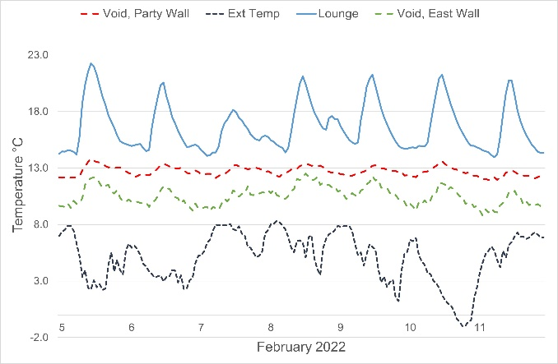 | 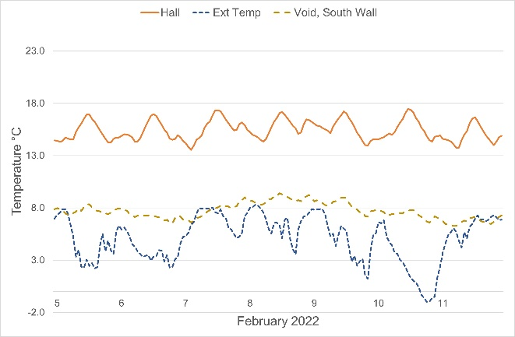
(c) Lounge, party wall and external wall void temperatures | (d) Hall and insulated external wall void temperature
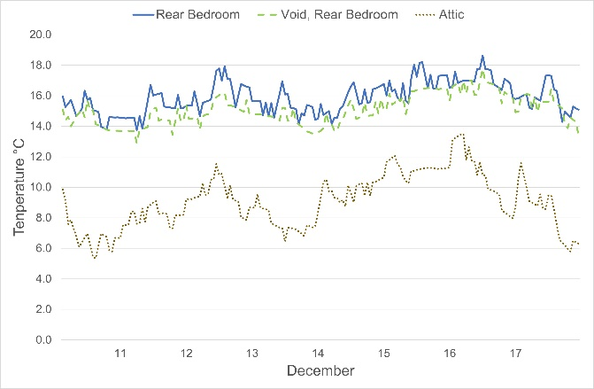 | 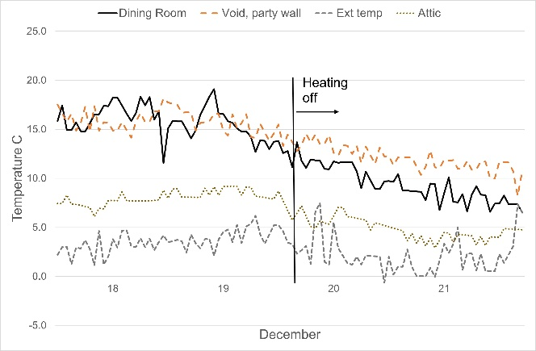
(e) Rear bedroom, partition void and attic temperatures | (f) Drop in temperature of party wall void when house heating shut off

The air temperature within the party wall ventilated void (Figure 3, (c)) is an average of 4.0 ° C below average room temperature. In contrast, the external wall void temperature is 6.1°C below room temperature. Both voids are open to the solum. This temperature difference in the party wall, compared to the external wall, represents a considerable heat loss from the house. Insulating party walls is often considered unnecessary, but these temperature readings indicate that the insulation of party walls is worthwhile.
Adjacent to the hallway, the external gable wall void was 7.7°C colder than the hall (Figure 3, (d)). The gable wall was insulated with 40 mm Celotex PIR sheet. This suggests that the insulation is reducing the heat flow through the wall, so the external stone wall and void are not being heated as much as in the lounge.
The upstairs rooms were also monitored (Figure 3, (e)). The most obvious aspect is the temperature difference between the attic and the room below, showing the importance of loft insulation. As with the ground floor, the temperature difference within the partition is similar to the room temperature. The temperature of the air in the floor void was also like the room. I made great efforts to ensure that the floor void was well sealed, by taping gaps in floorboards and sealing carpet underlay at the skirtings. In a previous flat, the carpet square on the newly sanded bare boards in the upstairs lounge used to hover like a magic carpet in windy weather.
On the morning of 20 December, we switched off the heating and left on holiday. Not only did the house room temperature start to fall, but so did the party wall void (Figure 3 (f)). It was no longer getting heat from our lounge. Heat from the house is therefore keeping both the party wall (and external walls) warm, wasting energy in the process. It is a sink rather than an insulator. While this serves to buffer void air temperatures, warming the void air in cold snaps and cooling it in warm weather, this is a waste of energy, that could be minimised by better insulated dry linings.
The readings show that heat is dissipated rapidly through the lath and plaster into the partition walls. If the partition walls are sealed, the heat will not dissipate further, except possibly to warm neighbouring rooms. Insulating sealed partition walls therefore makes no sense.
These results are valid for this house only. As I have commented above, in houses I have lived in, floors and partitions have leaked copious amounts of air, which will either need to be sealed or insulated. In spite of my strenuous efforts to seal the external wall house linings, it still leaked 7.2 air changes per hour when subject to a pressure of 50 Pa.
Heat loss model for my house
In 2014 I had an energy performance assessment carried out on my refurbished house. It achieved a D, 57. On reading the EPC I found that while the (visible) insulation in the loft and under the floor was considered in the assessment, all the (non-visible) insulation in the walls was not. As I want to improve on the D, 57 rating, I have developed a heat loss model specific to my house, where I can theoretically add insulation, to evaluate the reduced heat loss.
The basis for my model is to assume that the EPC, based on rdSAP, is correct for the insulation considered. The EPC provides a heat loss per annum in kWh. By dividing this gross amount by the number of hours in the year, I obtained an hourly heat loss figure. Knowing this, I found the average temperature difference (Δ T) across the walls and roof to achieve this heat loss. This then served as the baseline for my subsequent calculations. I have then added the insulation that was installed in practice, together with several other options to see their worth (Appendix 1).
Table 2. EPC evaluations after installing different types of insulation
Model  Number | Configuration | EPC rating | EPC  No | Heat out per hr | Annual heat output
 |  |  |  | kWh | kWh/an
1 | Insulation in loft and floor only⁽*⁾ | D | 57 | 5.24 | 45,902
2 | As 1, with installed PIR wall insulation | D | 67 | 3.98 | 34,850
3 | As 2, but with workshop insulated | D | 68 | 3.91 | 34,286
4 | As 3, but with windows triple glazed | C | 73 | 3.31 | 29,013
5 | As 3, but dining room party wall insulated with 60 mm PIR on top of L&P | C | 70 | 3.71 | 32,473
6 | As 1, but walls insulated as 3, but with 50 mm wood fibre, plus 10 mm wood fibre board covered with plaster board. | D | 64 | 4.43 | 38.833
7 | As 1, but totally insulated as 3, but with Orbis 60 mm PIR over L&P | C | 73 | 3.31 | 28,978
⁽*⁾ The U-Value used in this model for the composite 600 mm granite wall, a ventilated void and lath-and-plaster dry lining is an equivalent U-value of 1.2 W/m²°C, which recognises that the void temperature is increased by heat loss from the building’s dry linings (Pringle, RT, 2022).
The results suggest that had the insulation installed in the walls been considered by the EPC assessor, the EPC would have been D, 67 rather than the D, 57 given. The calculated heat loss would have been 34,850 kWh rather than the 45,902 kWh, stated.
Since the spare room we use as a workshop is only partly insulated, Model 3 shows the EPC increasing to D, 68 when insulated. Table 3 shows the heat transfer areas for the roof, floor, walls, etc, and the proportion of heat leaving the house from each of these areas.
For Model 4, the impact of changing the windows to triple glazing from double glazing increased the EPC rating from 68 to 73. While installing triple glazing to replace single glazed windows makes sense, replacing double glazed windows with triple probably does not. The possible reduced draughts through the triple gazing may however add to this benefit.
For Model 5, the dining room party wall is insulated, by removing the skirting, and applying PIR 60 mm board on top of the lath and plaster. This is the Orbis system (Aonach Architectural Energy Services)
Model 6 assumes that the house had been insulated with 50 mm wood fibre, plus 10 mm wood fibre board, topped with plasterboard. The EPC in this case is 64. Since the conductivity (Lamda) value of wood fibre is 1.64 times more than PIR, one would expect the EPC to be even worse. However, the bulk of the heat loss is from the uninsulated walls and windows (Table 3), so however much insulation is installed in the other walls, heat loss from these uninsulated walls still dominates.
Table 3. Routes for heat loss from the building using Model No 3.
Route for heat loss from each sector | Percentage area of building envelope where heat loss is occurring | Proportion of heat loss from each sector
 | % | %
Uninsulated walls | 16 | 26
Double glazed windows | 8 | 33
Insulated walls | 35 | 22
Floor | 20 | 11
Ceiling | 21 | 8
Total | 100 | 100

A practical problem with the wood fibre is that it is sold in 574 mm widths, suitable to be squeezed between studs at fixed intervals. Studs in traditional houses are neither truly parallel, evenly spaced nor the same spacing as the wood fibre sold, so fitting the fibre this way is not practical. If it is pushed in against the stonework, it could get wet if water flows down the inside of the wall, and it can also interrupt the essential airflow required (BS 2030) within the cavity (Figure 2). If it is cut to match the space, there will be lengths of wood fibre left over. In contrast PIR sheeting can be cut to size, with odd bits fitted and taped to the studs. Unless a system to overcome the limitations of wood fibre can be found, its use in such a situation is not recommended. Its poorer insulation value adds to this decision.
In Model 7, the house as in Model 1, was assumed to have had is walls insulated using the Orbis system, where lath and plaster is left in place, and the walls lined with 50 mm plus 10 mm PIR, followed by plasterboard. Compared to Model 3, the EPC rating rises from 68 to 73. This results in the insulation projecting into the room by the width of the PIR (60 mm) plus the plasterboard, 72.5 mm in total.
Heat loss from models
The predicted heat loss in the EPC assessment for my house (Table 4) was 45,902 kWh/an. With the wall insulation added, the model suggests the heat energy should be 34,286 kWh/an.
Smart meter readings for my house for 2021 showed a consumption of 12,950 kWh gas and 2,609 kWh electricity. Three cubic meters, or approximately 2.0 tonne of larch (Calorific value 16.0 MJ/kg) was also burnt.
Assuming the efficiencies stated in Table 4, all heat put into the house eventually comes out as heat loss, and electricity used in washing machines, appliances, TVs, microwaves and lighting end up as heat energy, again contributing to heat loss.
Table 4. Modelled and actual heat losses from the house
Item | Detail | Actual energy used | Efficiency | Heat loss
 |  | kWh | % | kWh
EPC heat loss | Loft and floor insulation only |  |  | 45,902
EPC heat loss with wall insulation included (A) | With wall insulation as installed in practice |  |  | 34,286
Utility bills (B) | Gas | 14,389 | 90 | 12,950
 | Electricity | 2,609 | 100 | 2,609
 | Logs | 8,888 | 75 | 6,666
 | Total |  |  | 22,225
Difference between A and B | Possibly affected by room zoning, rooms being less than 19°C, and some solar gain |  |  | 12,061

The EPC uses an average design room temperature of 21 °C in the living area, and 18°C elsewhere, both over a 9-hour period to calculate heat loss (Stroma, 2016). With the zoned heating system, parts of our house are often below this value, so the model will overstate the actual heat loss. There will also be some solar gain in the kitchen that is not accounted for. Loss of heat through adventitious ventilation is another.
Carbon footprint of insulation materials
There is disagreement within the architectural community as to what insulation materials should be used for internal wall insulation. This confusion is exemplified in publications like Sustainable Renovation (Morgan, C, 2019) where almost every wall illustration shows insulation being butted against plastered stone walls, quite unlike most walls found in granite properties (Figure 2). The presence of the ventilated void allows moisture to escape from the inside surface of the stone and allows the use of vapour impermeable oil-based insulation materials. This explains why the specification for the installation of energy efficiency measures in existing buildings (BS PAS 2030, 2017) stipulates that this cavity should be kept open and explains why few practicing architects would sanction obstructing this cavity with insulation for fear of future claims for wet or dry rot within the building structure.
Advice from traditional building professionals
During my 48 years of ownership of three successive granite properties, I have been subject to much advice as to how these houses should be maintained or refurbished. Being a scientist and engineer, I have always sought the logic in these recommendations. If the science is right the remediation should work. I address some of the recommendations below.
- Only use lime mortar in pointing granite walled buildings
Most slaters and builders I talk to use Portland cement while there is evidence (Historic Scotland, 2016) that we should all be using Natural Hydraulic Lime (NHL) 3.5 mortars when pointing walls. My own gable wall was repointed before we purchased the house in 2006 and had subsequently been treated with liquid sealant to stop apparent moisture ingress to the wall. In my subsequent efforts to find out why this gable wall has been constantly wet, slaters recently removed the chimney pots, rather than apply more cement. They then re-cemented the chimney pots on the chimney breasts, and the gable has subsequently dried out completely. The means by which the moisture in the wall escaped was either via the ventilated void, between the (probably lime mortared) stone and the lath & plaster, or via the (probably) Portland cement pointed external side of the wall. This possibly suggests that the use of Portland cement in the pointing of external walls is not such a heinous crime as many suggest, so long as the ventilated void is kept free of obstructions and the inside stonework is either left un-pointed or pointed in lime mortar.
- These houses need a good flow of ventilation through them
When I moved into my house in 2006, there were vents in the lath and plaster dry lining in the bathroom, vestibule, holes in trapdoors to the cellar, and elsewhere. I have sealed all these up.
Since cold air can only absorb small amounts of moisture from bathing, showering or cooking (Appendix 2), a good flow of air is required to keep towels dry and walls free from moisture. However, if outside air at 6 ºC, 90% is heated to 18 ºC, it can hold 12 times the amount of moisture that the same air can hold at its original state. This air can therefore hold both more moisture, and intermittent spikes of moisture, without needing ventilation. Vents in the lath and plaster or other dry linings, only serve to increase energy loss.
- Impact of central heating on a granite house
Since the skirtings, floorboards, door frames and doors are wood, the higher temperatures within centrally heated houses compared to the past, results in the timber drying out and shrinking. Gaps occur between floorboards, between the skirting boards, between their mouldings and between doors and their frames. The warmer the house, the more they shrink. One partial solution is not to run these houses too warm. The other is to seal these gaps up with filler, plywood sheeting, or sealing strips.
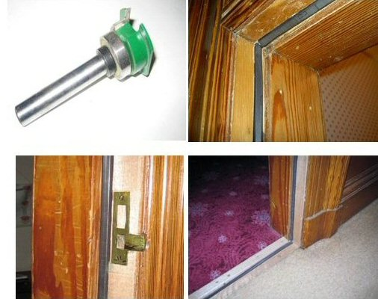
Figure 4. Aquamac seal
- Draughts
Many people in granite buildings are cold. In practice, it may be more about being in a draught, than the room temperature being too low. The worst places for draughts are where people sit between a door and a radiant fire or stove. I have used a high-speed router to fit seals to our door frames to take an Aquamac seal (Figure 4). The seal is special as it has no resistance to the door closing, as most seals do. The only problem is at the corners of the door, when the slot for the seal must be made manually with a narrow 2 mm and wider 10 mm chisel.
- Organic versus inorganic loft and floor insulation
The advocates for natural insulation materials prefer materials like sheep’s wool over glass fibre or rock wool. While I am a great advocate of biodegradable materials for food packaging and single use items, its use for insulation to last 100 years or so does not make sense. Since insulation in the roof space can on occasion get wet, natural materials may become an ideal breeding ground for insects or start to compost. Glass or rock wool being non-organic, does not have this problem.
Figure 5. Vernacular compatible with energy efficiency
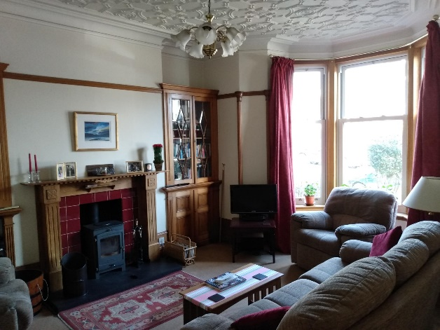 | 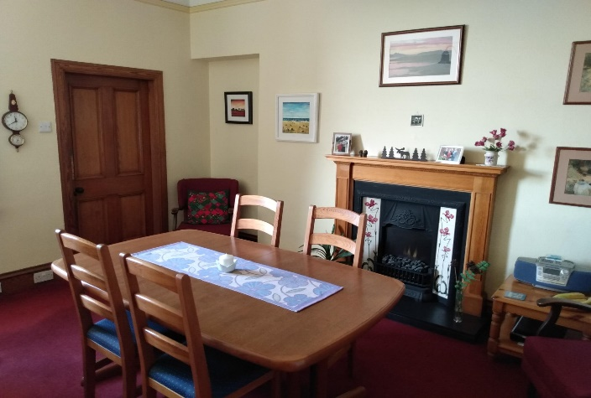
Lounge | Dining room
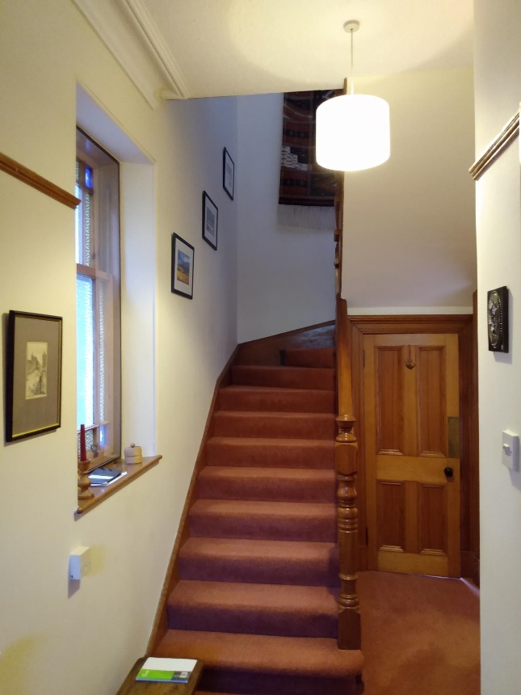 | 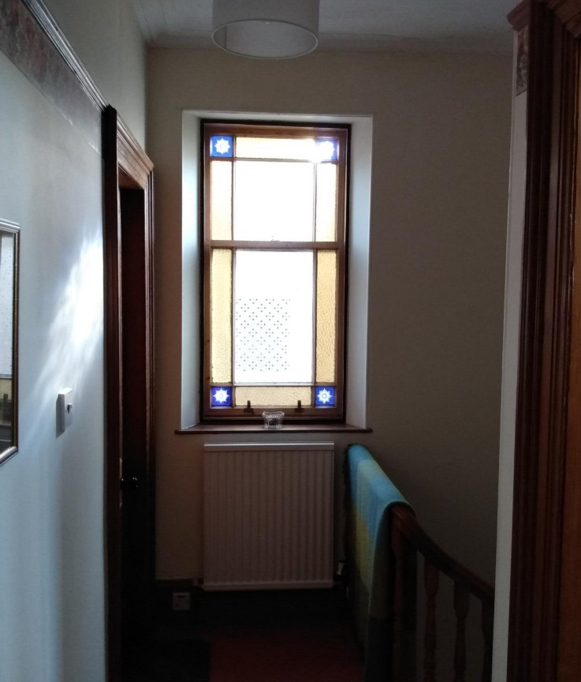
Hallway | First floor with Glaze and Save inner pane
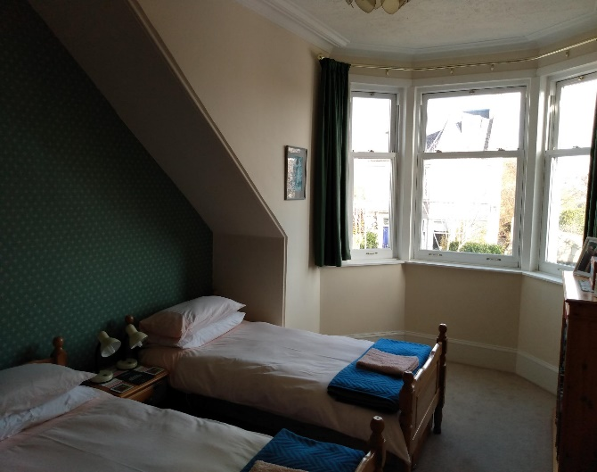 | 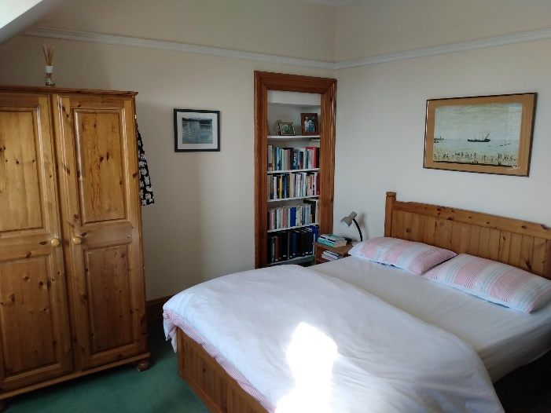
Front bedroom | Rear bedroom

- Heritage buildings
My wife and I have always preferred to live in granite houses because of their grandeur, their links with the past, and their appearance (Figure 5). However, in comparison with modern buildings, their heat loss, their maintenance, and their age all conspire to add cost to their owners and impose an energy use that impacts on the environment.
I tried to preserve wooden windows, traditional fireplaces, and historical features, but some have had to go. With the use of modern adhesives, wooden windows can be infinitely refurbished, but need to be fitted with seals to make them airtight and new counterweights installed to balance the heavier double glazed sash windows. However, regular repainting is required. I did install maintenance free, recycled, sash and case PVC, windows. Sadly, while the local supplier claimed that they were British Board of Agrement (BBA) certified for air tightness, they were not. Efforts to improve the seals have been only partially successful. PVC when burnt produces dioxins, so if used should be recycled into new windows. I now regret not having installed wood cored, Velfac / NorDan maintenance free windows throughout the house.
The open fire, 20% efficient, is now a stove that is 75% efficient. The use of high thermal resistance PIR sheet insulation covered by plasterboard, allows the timber skirtings, and features to remain and significantly reduces the heat loss and impact on climate change. Minimising global warming must take precedence over some loss of the vernacular.
Planned developments
As a result of these deliberations, I will insulate my workshop with PIR insulation behind the skirting so that it is similar with the insulation in the other bedrooms. It is a small job. I will get Aonach Architectural Energy Services to install 50-60 mm of PIR insulation in my dining room party wall, prior to us redecorating the room. During the redecoration I will seal the carpet underlay where it meets the skirtings. This added insulation should bring the house up to an EPC rating of C, 70. Hopefully, by the time I do this, the recommendations proposed (Alembic Research Ltd et al., 2019) will have been acted upon.
I intend to keep my Glow worm boiler, in the hope that natural gas will be substituted by biogas, from the new anaerobic digester near P&J live (TECA). That way, the zoning system we use to minimise our energy use, can continue.
If the city decides not to maintain a gas network to this side of town, we can install either an air source heat pump or, better, a vertically drilled ground source heat pump, with access from the allotment adjoining our back garden.
To match the heat pump, an underfloor heating system could be installed via the 1.6 m headroom cellar, so that no lifting of the floor is required. If the existing radiators downstairs are in good enough condition, they may be removed and installed upstairs to heat the bedrooms and workshop.
If this were done, it may be beneficial to add to some of the existing insulation, as with the heat pump it is usual for the house heating to be kept on continuously.
Using my house to project into the whole Scottish situation
In Scotland there are 480,000 detached, semi-detached, terraced, tenement, and flats built before 1919, the large majority needing upgrading to make them zero carbon by 2045. Since the large majority will need refurbishing by 2033, when the Scottish Government (Scottish Government 2021) is suggesting that all homes will have an EPC of C, this requires 44,000 houses to be refurbished per year, starting now.
Conclusions
These conclusions relate specifically to this house and its construction detail. Other granite houses could behave differently. The model suggests that the house could achieve an EPC in the low to mid Cs. The temperature monitoring, backed by the models, emphasise the poor insulation value of lath and plaster. Heat energy flows through the dry lining, into the ventilated void, only to be wasted heating the granite walls and the wind passing through.
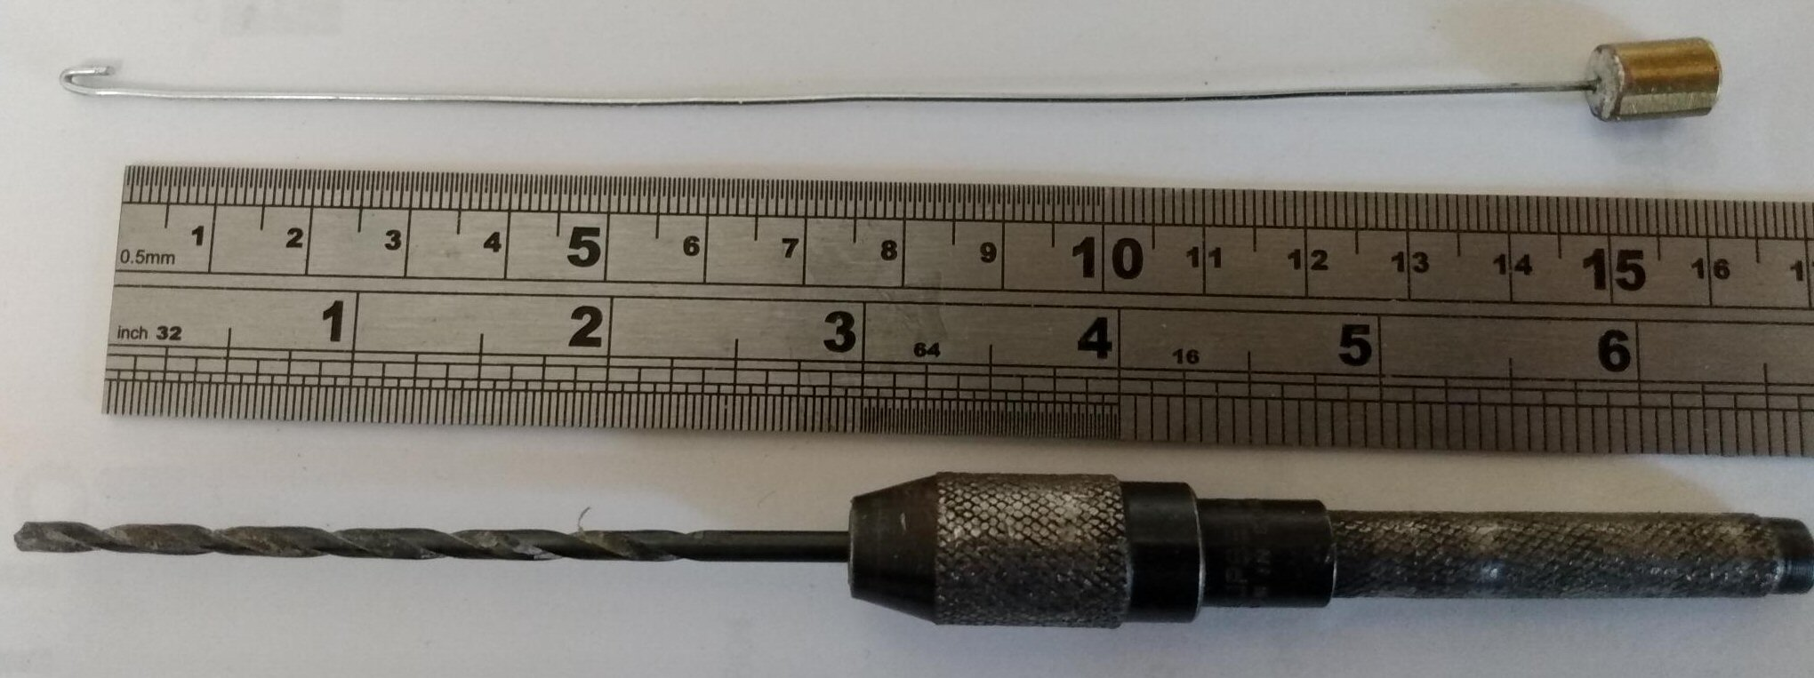
Figure 6. Finger drill with 3 mm bitt plus wire with hook gauge
The comparison between the actual metered energy used to heat the house and the heat loss predicted by the rdSAP model, shows lower heat use than the model predicted, probably due to the room temperatures being below the model assumptions and our heat zoning system. The failure is the questionable instruction to EPC assessors that they should not drill holes in walls to identify wall insulation type and thickness. (Scottish Government, 2019). A safe method of validating installed insulation (Figure 6) can be achieved by finger drilling plasterboard and PIR with a 3 mm drill bit, then using the 1 mm thick wire device with a hook end, to measure its thickness. Checking insulation via electrical sockets is another.

The partition walls and the void in the first floor were effectively well sealed boxes. Their temperature closely followed adjoining room temperatures. The warm air did not migrate from the ground to the first-floor rooms. There is therefore no sense in insulating partition walls. As most doors are in partitions, this allows the door frames and skirtings to remain undisturbed during renovations.
Some sealing of electric cable and plumbing entry points may be necessary if the air in partition wall voids was found to be cold due to excessive air flow.
The presence of the ventilated void between the rough granite walls and the lath and plaster allows moisture from the wall and vapour through the dry lining to be carried away by the mainly wind induced ventilation. This allows both vapour resistant and porous insulation to be used to replace, or be added to, the lath and plaster.
Over an assumed 50-year insulation material life, the energy savings over the continued use of lath and plaster will hugely exceed the embedded energy for PIR insulation and wood fibre insulation respectively. The embedded energy is therefore insignificant.
The insistence on using less effective insulation materials such as wood fibre rather than PIR materials, means that the walls of these wood fibre insulated building walls will emit 68% more energy than those using PIR, using the same thickness of material. If we are to minimise climate warming, we need to use the most effective insulation materials available.
The larger granite buildings are hugely flexible. Factories become homes, homes become offices, and schools become hotels. Their facades, woodwork, craftmanship and beauty can be modified to make them warm, comfortable, and practical, while still retaining the links to the past. Owners want practical, low maintenance, buildings, unrestricted by regulations imposed by those more concerned with our heritage than the survival of our planet.
Architects, building surveyors and builders are rightly nervous about creating conditions where condensation occurs, for mould and rotting to develop. The presence of the ventilated void and ventilated attic provides a vital escape route for any moisture or condensation that does occur. This is what BS 2030 stipulates, that these voids should always be kept open for free movement of ambient air.
Within the insulated structure, the danger is not so much the relative humidity, but the presence of cold surfaces where vapour may condense. The warm air in modern houses can hold considerable moisture. If all surfaces are well insulated and are free from cold bridges, condensation on walls and windows can be avoided.

Appendix 1. Calculating additional EPC values in addition to initial EPC
The EPC allocated to my house was EPC D, 57. If a building were to emit no heat at all, the EPC would rise to 100. Figure 6 shows this in diagrammatic form.
The length H₁ is the annual average heat loss (kWh/hr) of my house as stated in the EPC. The length E is (100 – EPC), with the EPC being 57.
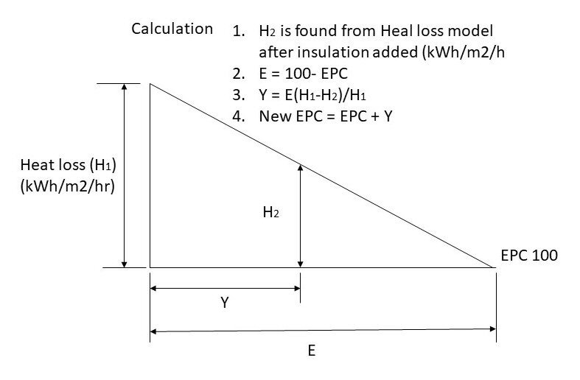
Figure 6. Calculation of improved EPC using heat loss model
By knowing what insulation was considered for the rdSAP model, the relationship between heat loss and EPC rating can be established.
The heat loss model is then used to theoretically add insulation to the house to see how this will change the heat loss from the house and what the resulting EPC will be.
If the calculated heat loss is H₂,
Y = E(H₁ – H₂)/H₁
and the “New EPC” = EPC + Y.

Appendix 2. The drying capability of room air
When these granite buildings were built, the rooms were heated by coal fires when occupied. The unoccupied rooms were not heated. To keep bathroom towels dry and walls free from moisture and mould, the practice was to have plenty ventilation.
With ambient relative humidity in the nineties, and temperatures of 6 °C, the water holding properties of air are minimal. In a bathroom 2m x 3m and 3m high, air at 6 °C, 90% relative humidity (RH) can hold 14 ml of water, about one tablespoon.
With the advent of central heating, room temperatures are usually about 18 °C. If air at 6 °C 90% is heated to 18 °C, its RH reduces to 42.6 %. Instead of being able to hold 14.1 ml of water it can hold 172 ml, about 12 tablespoons, and 12 times the amount that the colder air can hold.
The warmer air can therefore hold much more moisture than cold air. Excessive ventilation only serves to waste heat. Where ventilation is needed is between the internal insulated box that makes up the living area and stone structure, to ensure that the walls remain dry and the timber structural components remain rot free.
References

Alembic Research Ltd, Energy Action Scotland, Dr Patrick Waterfield, 2019. A review of domestic and non-domestic energy performance certificates in Scotland: Research report for the Scottish Government, Heat, Energy Efficiency and Consumers Unit: Final Report

Aonach Architectural Energy Services. http://www.aonach.org.uk/

BS PAS 2030,2017. Specification for the installation of energy efficiency measures in existing buildings

BS PAS 2035, 2019. Retrofitting dwellings for improved energy efficiency. Specification and guidance. Specification for the installation of energy efficiency measures in existing dwellings and insulation in residential park homes

Celotex insulation product specifications. https://insulationmerchant.com/collections/walls?constraint=celotex

CIBSE, (2005). Heating, ventilating, air conditioning and refrigeration. Pp 429. ISBN 1903287588

Historic Scotland, 2016. Lime and cement in traditional mortars. Inform guide. pp 8.

Morgan, Chris, 2019. Sustainable Renovation: Improving homes for energy, health and the environment. Dingwall: The Pebble Trust.

Pringle, RT, 2015. Improving the energy efficiency of a traditional stone house. Edition 3. pp 77. https://www.sustainability-in-practice.org.uk > Home energy

Pringle, RT, 2022. Wall insulation value of a traditional granite house. pp 6. https://www.sustainability-in-practice.org.uk > Home energy

Scottish Government, 2019. Energy Efficient Scotland: improving energy efficiency in owner occupied homes. December. pp 57

Scottish Government, 2021. Heat in buildings strategy. October, pp18

Steico-Flex Insulation product specifications. https://insulationmerchant.com/collections/natural-insulation/products/steico-flex-036-575x140. Accessed 21-02-22.

Stroma Certification, 2016. rdSAP Manual. www.Stroma.com
Bob Pringle
BSc, MSc, Chartered Engineer bobpringle@btinternet.com 26/08/22

