Wall Insulation value of a traditional granite house
Abstract
The U-value of a granite wall, with ventilated void and plaster-on-lath dry lining cannot be treated in the same way as a composite wall, as the stone wall traps heat escaping from the building floor, walls and ceiling, warming the void space air temperature and so reducing the temperature differential across the plaster-on-lath. Wind induced ventilation removes a proportion of this heat in cold weather, cooling the void air temperature in exposed sites. While this represents the true situation for predicting heat loss from the building, the complexity involved in predicting these heat flows is too great to get an accurate value of EPC. It is therefore best to stay with heat flux measured effective U-values of the wall/void/plaster, so long as it is realised that their values do not take into account exposure or heat losses from other parts of the building structure.
Introduction
In calculating the Energy Performance of a traditional Scottish granite building to establish its EPC rating, the U-Value for a granite wall, a ventilated void and plaster on lath lining have been the subject to much discussion recently. This paper aims to clarify why this issue is complex and suggests a resolution.
An unheated house.
Before considering the energy losses from a heated granite house, we first need to consider how an unheated house will behave. The temperature of the stone walls and rooms will follow ambient temperature but with the temperature of the inside of the stonework exhibiting a thermal lag. In summer this is noticeable by the interior being cooler than outside on hot days and warmer inside than outside on cold days. The south facing outer surface of the walls are warmed when the sun is out. Of greater importance, solar gain will warm the loft space and radiate through windows to warm south facing rooms. The walls serve to reduce the ambient temperature range that the dry linings see.
A heated house
In a heated house, any significant temperature increase above ambient within the cellar, ventilated voids, party walls and external walls is due to conduction and radiative heat from the house’s heating system.
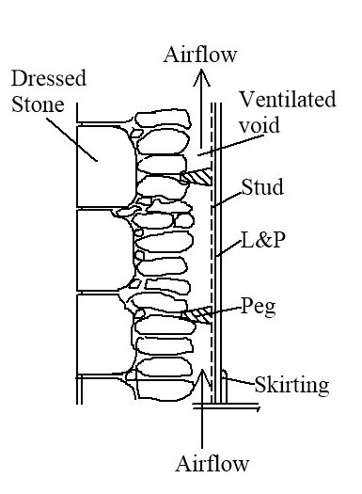
Wind and convection will cause air to flow through these voids (Figure 1), the former removing heat from these air spaces and the latter distributing the warmed air to the rest of the void and roof space via convection.
The components of heat and air flows to and from the solum, wall voids and loft space are shown in Figure 2. The most variable of these is the airflow due to wind. In high winds with a direction at 90 degrees to the ridge of the roof, the temperature in the windward wall void will approach ambient temperature if there are there are wall vents in the structure. In this case, the temperature difference across the plaster-on-lath will be a maximum, maximising heat loss.
Figure 1, X-Section of a granite and lath- on-plaster wall with a ventilated void
On still days, in sheltered sites, the void temperature will reach a maximum, with the various heat flows from the house accumulating, to warm the void air. The temperature difference across the plaster-on-lath will then be a minimum, causing heat loss to be a minimum.
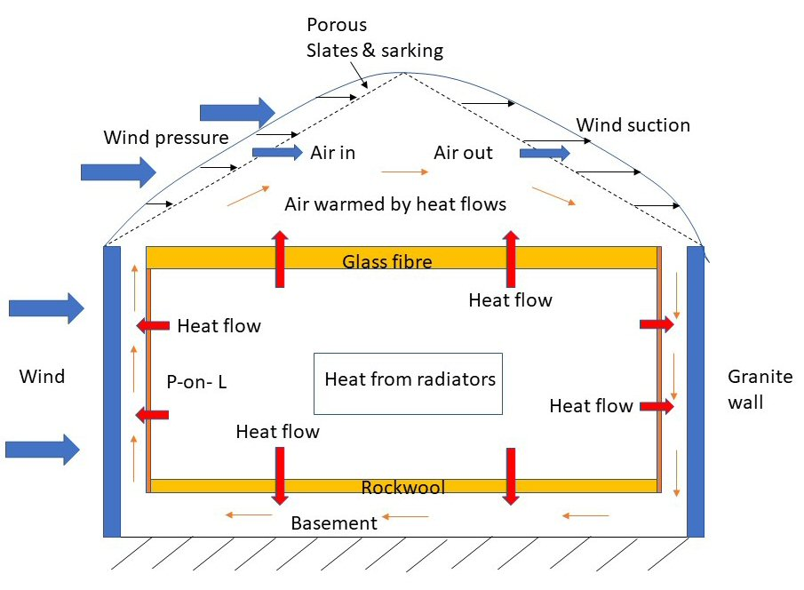
Figure 2. Heat flows in and out of the ventilated void between the granite wall and plaster-on-lath
Use of heat flux meter to establish wall U-values
Work done between 2008 and 2012 by Glasgow Caledonian University and Historic Scotland (Baker, 2011) using a heat flux meter to determine the heat flow through the walls was rigorous and detailed. However, the restraint imposed by not being able to knock holes in the dry lining, meant that the air temperature and air speed in the void was not monitored. Only the heat flux through the dry lining was measured. The measurements were therefore blind to differing conditions within the void. The monitoring with the heating on was continued for a period so that a steady state condition could be achieved.
The heat flux (H) is normally expressed by the equation: -
H = U * A * ΔT,
Where U = the U-value of the wall (W/m²°C or W/m²°K)
A = Area of the wall (m²)
ΔT = Difference in temperature between the inside and outside of the wall (°C)
H = Heat flux (W/m²)
In a wall without a void, the U-value is a fixed value which can be calculated by combining the insulation values of the wall components. However, in a wall with a void, which is freely ventilated with ambient air, the insulation value becomes a variable. Wind pressure on the building and thermal buoyancy within the cavity cause air to flow within the void, causing the U-value of the wall to vary..
With the heat flux meter, the heat flow is measured directly with a sensor affixed to the wall lining. A series of tests in different Scottish buildings were undertaken and a range of values of U_{v} were obtained. A figure of 1.20 W/m²°C has been selected (Baker 2011) as the average in Table 2 of this document of 13 readings (Victoria villa, Stalkers Cottage, Castle Fraser, and McGowan house), having 600 mm walls, a ventilated void and plaster-on-lath inner lining. The range was 0.60 to 2.00 W/m²°C
As this figure takes no account of the degree to which the cavity is ventilated, no factor can be input to represent sheltered or exposed situations. It would therefore be better to use the actual U-value of the dry lining, usually plaster-on-lath, and then allocate an exposure factor for the building being considered.
The calculated U-value of plaster on lath is 3.69 W/m²°C. If the two different methods of calculating the heat flux are compared, we can find what the void temperature was during the monitoring.
H = U_{C} * A * ΔT --------------- Equation 1
Where: -
U_{c} is the U-value of the composite wall, void space and plaster-on-lath, found by heat flux meter
ΔT is temperature difference between room and ambient air temperature

H = U_{p} * A * (ΔT- X) -------------- Equation 2
Where: -
U_{p} is the calculated U-value of the plaster-on-lath
X is the elevated temperature above ambient in the void space due to the heat escaping from building and trapped in the void
Since Equations 1 and 2 should give the same result,
i.e Uc ΔT = Up (ΔT-X)
= Up ΔT – Up X
Therefore, Up X = (Up – Uc) ΔT
Or, X = ΔT (Up-Uc) / Up
= ΔT (3.69-1.20) / 3.69
= 0.69 ΔT
The heat flux is proportional to the temperature difference between the internal room temperature and the void air temperature. While the U-value of the plaster-on-lath is a constant, calculated as 3.69 W/m²°C, the temperature difference between the room temperature and the void is a variable, affected by the external air temperature but also by the degree of air leakage from outside, and heat from the walls and floor.
Why the heat flux is less than would be expected if the building had no external wall, but only plaster on lath, is that the heat flows through the building floor and the room plaster-on-lath linings, together with leakage through gaps in the plaster-on-lath is being trapped in the voids, raising void air temperature. In still days or in a house well sealed to wind, this void air temperature rise will be higher than on windy days or poorly sealed houses, when it will be small.
It is important to recognise that the role of the wall is in trapping heat lost from the building floor and walls, not in its thermal resistance. Increasing the wall thickness will have little impact on reducing heat loss from the house. What will have an impact is the velocity of the air through the void space, which serves to remove heat escaping from floors, walls and leaks in walls, thereby increasing the temperature differential between room and void, and its resultant heat flux.
The present data (Gov.Scot 2019) suggesting that stone walls with voids and plaster on lath linings reduce their U-value as the thickness of the stone wall increases is not credible. Historic Scotland should give up this line of argument.
How to determine the heat loss from a stone wall with a ventilated void
What is wanted for the SAP model used to determine the building EPC is a heat loss figure that can be used to give an average heat loss for the building over a year. The model considers the climate temperature variations throughout the year, the day degrees needed to keep the house at temperature, and averages this over the year to get an EPC rating. However, to differentiate between two houses, one sheltered by other houses and one in an exposed site, a factor for void ventilation and its impact on void temperature should be available.
In most houses the heating is switched on with a time clock, with the room temperatures controlled by radiator thermostats. When heating is switched on, the heat flowing through the walls and floor will start to heat the void air by conduction and the adjoining stone wall by conduction, convection and radiation. As a result, the temperature of the void air will rise. This will cause the heat loss through the plaster-on-lath (dry lining) to reduce as the temperature differences between the rooms and the void reduce.
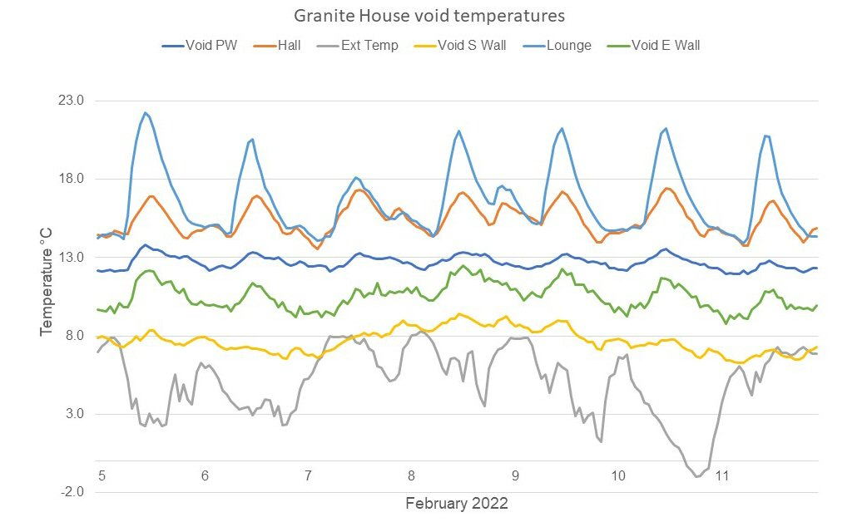
Figure 3. The room, ventilated voids and external temperatures for my granite house, 5- 11 February, 2022
A graph showing room, void, and external temperatures (Figure 3) for my house (Pringle, RT, 2022) over one week in February shows how temperatures vary when the room is lined with plaster-on-lath. The wood stove in the lounge is lit most evenings. The 24-hour average temperature differences above ambient in the voids adjoining the lounge are 7.8 C, party wall, and 5.4 C external wall. In the hall, which was 1.3 C cooler than the lounge, the void temperature in the 40 mm PIR insulated external wall averaged 2.6 C, showing that the superior lining insulation significantly reduced the heat loss to the void.
These are 24/7 averages. However, the heating in the lounge was only on between 6 to 10.30 pm. The other rooms were programmed to come on when occupied, with heating manually switched on during mornings and afternoons on cold days.
If the heat flux measurements give the wall U-value at 1.20 W/m2/° C, and the actual U-value of plaster on lath is 3.69 W/m2 ° C, the air temperature in the void would be 0.69 x ΔT °C for the average measurement.

Table 1. Measured void / ambient temperature differences for Aberdeen granite house between 18-24 hrs, 5-11th February, 2022.
Date | 5 | 6 | 7 | 8 | 9 | 10 | 11
Log fire |  |  | Off
0.69 ΔT | 13.0 | 11.1 | 7.2 | 10.5 | 10.0 | 13.2 | 8.6
< Max | 3.3 | 3.3 | 3.8 | 3.1 | 3.3 | 3.0 | 4.4
Hrs
24 | 9.7 | 7.8 | 3.4 | 7.4 | 6.1 | 10.2 | 4.2
23 | 9.1 | 8.4 | 3.4 | 5.9 | 6.3 | 9.9 | 5.5
22 | 9.8 | 7.5 | 2.4 | 5.3 | 5.5 | 9.3 | 4.2
21 | 9.5 | 7.1 | 2.2 | 5.5 | 6.2 | 8.0 | 5.1
20 | 7.6 | 6.8 | 2.3 | 5.6 | 6.8 | 7.8 | 4.7
19 | 7.0 | 6.4 | 1.9 | 5.0 | 5.5 | 6.5 | 4.3
18 | 4.6 | 5.7 | 1.3 | 3.6 | 5.2 | 6.1 | 4.0
Wind spd (mph) | 12 | 17 | 10 | 10 | 13 | 10 | 20
Direction | WSW | WNW | W | SW | SW | WNW | S

The monitored temperature data (Table 1), shows the actual difference between ambient and external wall void air between 1800 and 2400 hrs for 7 consecutive nights. Room heating was switched on at 1800 hrs. The temperature in the void increased during this period, probably due to the void granite wall surface warming. The void air temperature peaked at between 23 to 24 hours, then cooled once the heating was switched off
The results from Table 1 suggest a maximum void temperature above ambient for midnight for each of the seven days. These values are shown in red, and were calculated using the equation 0.69 ΔT, where ΔT is the difference in measured temperature between the lounge and ambient. That the actual temperatures above ambient averaged 3.4 C, also in red, below this temperature suggests that wind was impacting in reducing this temperature. My house is very exposed to the west, but I have fitted a close-fitting door with routed in Aquamac seals, to minimise air entry into the basement. Some ventilation is highly likely however. That the wind speed was relative similar on many days may explain the 3.4 C reduction is constant over the week.
Better model for building energy loss from granite, void and plaster on lath walls
While the logic of the above approach makes more sense than suggesting that thicker stone walls provide lower U-Values, we are left with the problem of having standard values for air leakage and infiltration. The degree of leakage depends on the wind strength, the building exposure, its orientation with respect to the prevailing wind, the vents and gaps in the building walls, and the porosity of the roof. Some estimate could be achieved with computational fluid dynamics (CFD) or using a wind tunnel, but this would require an input that may not be justified.
The continued use of the U-value of 1.2 W/m₂°C may be the easiest way of giving approximate EPC values, so long as its limitations in explaining the science is recognised.
Bob Pringle, BSc Mech Eng, MSc Agric Eng, CEng
bobpringle@btinternet.com

References
Gov.scot, 2019. Domestic and non-domestic energy performance certificates review: supplementary notes.
Baker, 2011. U-values and traditional Buildings: In situ measurements and their comparisons to calculated values. pp70. Historic Scotland technical paper 10.
Pringle, R T, 2022. Preparing a traditional Scottish granite house for 2045 zero carbon. Zero carbon home-2045.docx pp 12. https://sustainability-in-practice.org.uk/three-to-two-planet-living/home-energy/

